Condensing Boiler Condensate Drain Arrangements

Further to the notice dated 21st March 2006 we have consulted with the main boiler suppliers for Warm Front. All have confirmed that where condensate discharge pipes discharge into rainwater down-pipes they must terminate above ground level in an open gulley unless a soak-away is used. This is to prevent any rainwater backing-up due to blocked drains or exceptionally heavy rainfall, thus allowing the rainwater to back-up and eventually get back into the boiler, as has happened on a few occasions this year.

Please ensure that all where you install boiler condensate drains into a drainage down-pipe that is not a soil vent pipe or does not terminate in a soak-away, that the down-pipe terminates above the drain water level in a surface gully and any drain blockage will not allow the drain to back-up and flood the boiler. Where there is any boiler failure as a consequence of not following the boiler manufacturer’s correct condensate drain installation procedure the cost of repairing or replacing the boiler will be reclaimed from the installing company.

We attach the condensate discharge pipe connections required by Ideal, Vaillant and Baxi.

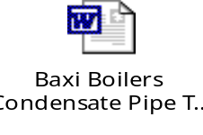

We appreciate that there are occasions where the only possible or the best possible connection is into a rainwater down-pipe that goes directly into the drains without going into an open gulley. In these cases we have found installers making use of the following type of connection via an elbow fitted into the rainwater down-pipe.
Ground level
Condensate pipe from boiler

Rainwater down-pipe

Gap to allow rainwater back-up to overflow

Elbow inserted into socket

Socket, solvent welded or otherwise fixed to rainwater down-pipe

Regards,
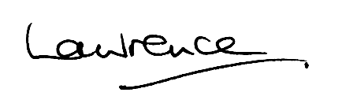

Lawrence Connelly
Installer Manager
8th August 2006

